Dom Document Object Model Section 7
https://www.udemy.com/course/modern-javascript-from-the-beginning/learn/lecture/37191962#overview
68 Intro – Interact with page elements with javascript -properties and objects available on the DOM , traversing and navigating the DOM
69 Intro to the DOM
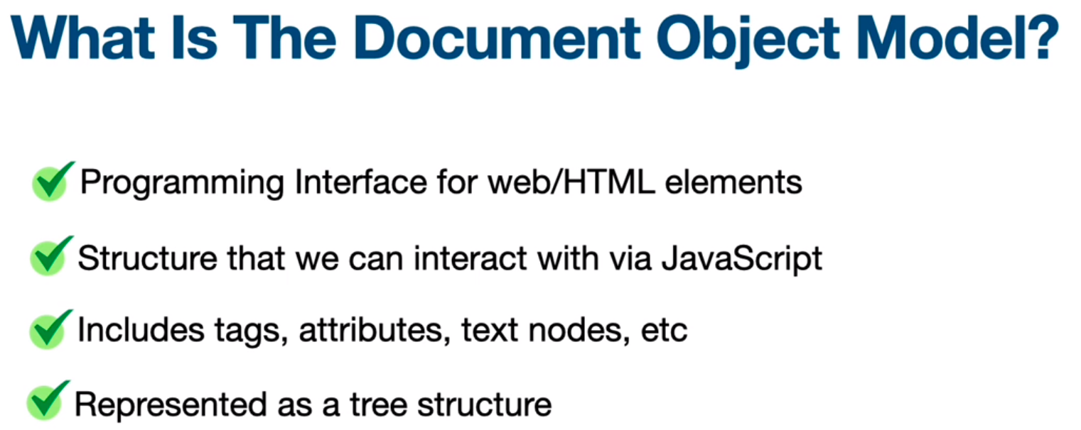
Tree structure
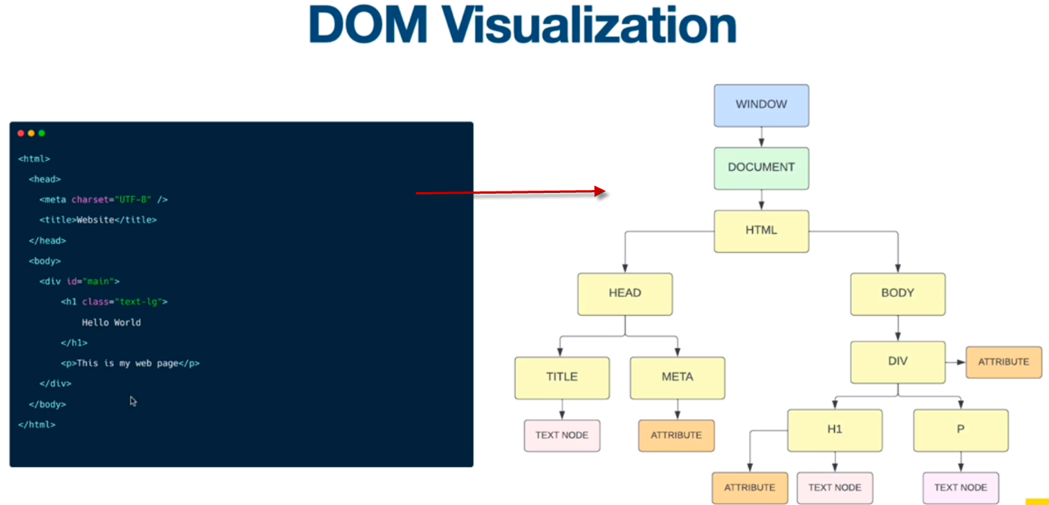

HTML collection is very similar to an array , can access using index
can set properties of elements using : document.body.innerHTML = '<h1>Hello from body</h1>';
or .innerText to just add some text
Methods
document.write()
document.getElementByID()
document.querySelector()
70 Document Element Properties
Can use to access and do stuff with javascript but usually would use getElementByID or queryselecor ect
document.body.children – the children directly in the body
HTML collection is array like but cannot use array methods like forEach on it. When using querySelector have access to the Node list it is also array like and can use forEach on a nodelist –
Note : You can loop through a NodeList and refer to its nodes by index. But, you cannot use Array methods like push(), pop(), or join() on a NodeList.
NodeList – browser API
Array – javascript API
Use array from method to turn a node list into an array
const forms = Array.from(document.forms)
71 DOM Selectors – single elements
document.getElementById( ) method of the Document interface returns an Element object representing the element whose id property matches the specified string. Since element IDs are required to be unique if specified, they're a useful way to get access to a specific element quickly. If you need to get access to an element which doesn't have an ID, you can use querySelector() to find the element using any selector. Unlike some other element-lookup methods such as Document.querySelector() and Document.querySelectorAll(), getElementById() is only available as a method of the global document object, and not available as a method on all element objects in the DOM. Because ID values must be unique throughout the entire document, there is no need for "local" versions of the function.
getAttribute()
.setAttribute()
querySelector()
id is an available property , but does not work for every single attribute…
for example .class would come back undefined , there is a className property that works. The getAttribute() method and pass the attribute in there.
.setAttribute() - takes in attribute you want to set and what you want to set it to.
Can also change content and styles
textContent
innerText
innerHTML
no hyphens allowed in javascript so use camelCase to change styles from the javascript
style.backgroundColor = 'black'
document.querySelector() – this was a game changer when it came out because one did not always have an ID (that is why people used to use jquery – don’t really need jquery any more as a dom manipulator)
can also use a psudo selector like nth-child
console.log(document.querySelector("li:nth-child(2)").innerText);
72 DOM Selectors – Multiple Elements
querySelectorAll() -the go to used almost 100% of the time, there are others but this is the most used.
- Returns a node list
- Can use forEach() on the node list , and other higher order array methods
getElementsByClassName() – returns a live HTMLCollection which contains every descendant element which has the specified class name or names.
getElementsByTagName() – method returns a live HTMLCollection of elements with the given tag name.
.remove() The Element.remove() method removes the element from the DOM.
Array.from() The Array.from() static method creates a new, shallow-copied Array instance from an iterable or array-like object.

73- Traversing the DOM Elements – any HTML tag on a page is an element, relationships parent >children . Divs on same level are siblings
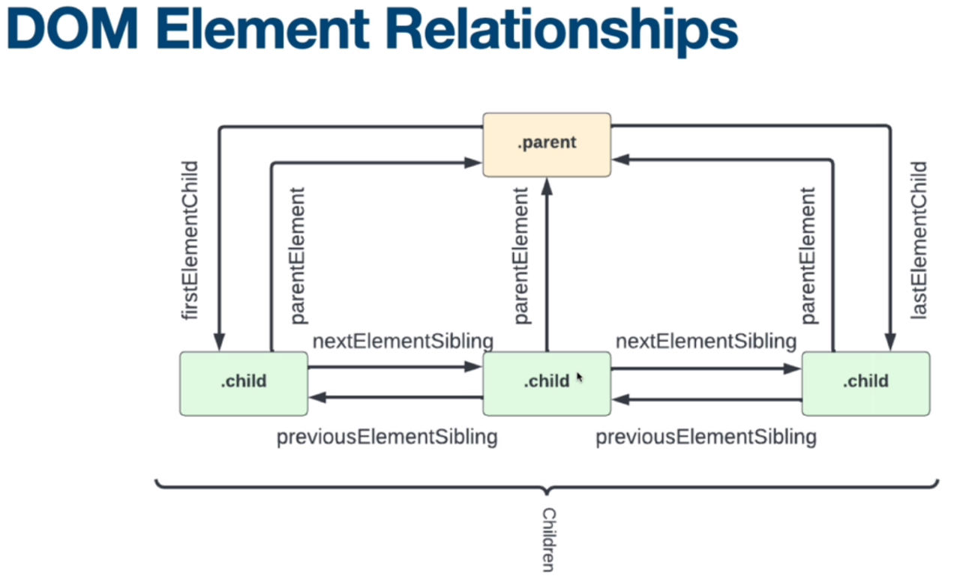
.children - a property not a method – it returns an HTMLCollection, can get to each of the individual elements using an index
Also have available – see diagram above
.firstElementChild The Element.firstElementChild read-only property returns an element's first child Element, or null if there are no child elements. Element.firstElementChild includes only element nodes. To get all child nodes, including non-element nodes like text and comment nodes, use Node.firstChild.
.lastElementChild The Element.lastElementChild read-only property returns an element's last child Element, or null if there are no child elements. Element.lastElementChild includes only element nodes. To get all child nodes, including non-element nodes like text and comment nodes, use Node.lastChild.
.parentElement Can get the parent element of a child with parentElement property read-only property of Node interface returns the DOM node's parent Element, or null if the node either has no parent, or its parent isn't a DOM Element.ValueAn Element that is the parent element of the current node, or null if there isn't one.
.nextElementSibling read-only property returns the element immediately following the specified one in its parent's children list, or null if the specified element is the last one in the list.
. previousElementSibling read-only property returns the Element immediately prior to the specified one in its parent's children list, or null if the specified element is the first one in the list.
74 Traversing the DOM - Nodes 12 of them
Element is a type on node and the most common, other common ones are. Text nodes and Comment nodes.
Can use noteType property to console.log the type of node – it returns a number that represents the type of node – column one below
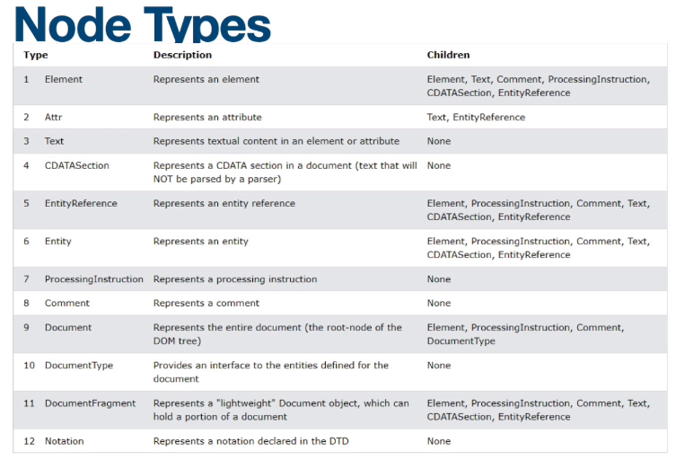
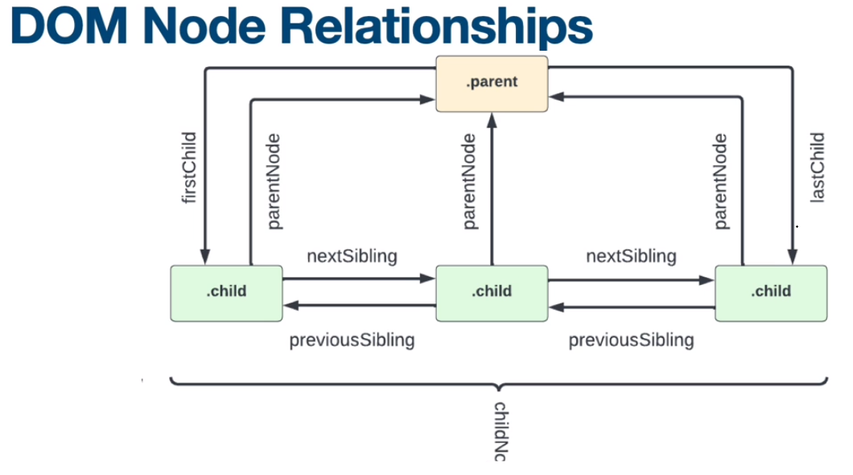
Properties on the node list (not an HTML collection):

.childNodes -The read-only childNodes property of the Node interface returns a live NodeList of child nodes of the given element where the first child node is assigned index 0. Child nodes include elements, text and comments.
Text – white space counts as text
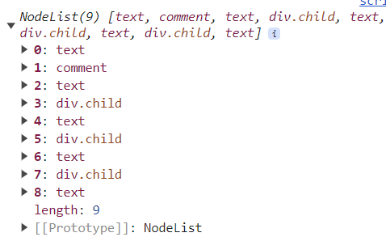
.firstChild property of the Node interface returns the node's first child in the tree, or null if the node has no children.If the node is a Document, this property returns the first node in the list of its direct children.
.lastChild property of the Node interface returns the last child of the node, or null if there are no child nodes.
.parentNode -property of the Node interface returns the parent of the specified node in the DOM tree. Document and Document Fragment nodes can never have a parent, so parentNode will always return null. It also returns null if the node has just been created and is not yet attached to the tree.
.parentElement -property of Node interface returns the DOM node's parent Element, or null if the node either has no parent, or its parent isn't a DOM Element.ValueAn Element that is the parent element of the current node, or null if there isn't one.
.nextSibling property of the Node interface returns the node immediately following the specified one in their parent's childNodes, or returns null if the specified node is the last child in the parent element. White space issue -You can use Element.nextElementSibling to obtain the next element skipping any whitespace nodes, other between-element text, or comments.
.previousSibling property of the Node interface returns the node immediately preceding the specified one in its parent's childNodes list, or null if the specified node is the first in that list White space issue - You can use previousElementSibling to get the previous element node (skipping text nodes and any other non-element nodes).

75 Create and Append Elements – can create and inject elements into the DOM using JS – like inserting based on an event.
.createElement() -pass in the element desired in quotes - In an HTML document, the document.createElement() method creates the HTML element specified by tagName, or an HTMLUnknownElement if tagName isn't recognized.
Syntax
createElement(tagName)
createElement(tagName, options)
.setAttribute() – instance method- Sets the value of an attribute on the specified element. If the attribute already exists, the value is updated; otherwise a new attribute is added with the specified name and value.To get the current value of an attribute, use getAttribute(); to remove an attribute, call removeAttribute().
Syntax
setAttribute(name, value)
name
A string specifying the name of the attribute whose value is to be set. The attribute name is automatically converted to all lower-case when setAttribute() is called on an HTML element in an HTML document.
value
A string containing the value to assign to the attribute. Any non-string value specified is converted automatically into a string.

.createTextNode() - Creates a new Text node. This method can be used to escape HTML characters.
Syntax
createTextNode(data) - data is a string containing the data to be put in the text node \
Put it on the DOM
.appendChild() – instance method on the Node interface adds a node to the end of the list of children of a specified parent node. This method is used a lot !!!

76 InnerHTML vs createElement() -
Solving using InnerHTML - when solving this way the browser needs to parse and recreate all the DOM nodes inside the UL element. So less efficient than creating new elements and appending them. Also when doing this way HTML will not automatically re attache event handlers to the new elements , so would have to be tracked manually
Uncaught TypeError: Failed to execute 'appendChild' on 'Node': parameter 1 is not of type 'Node'
Getting this error is due to trying to append the li string, have to create the element node first.
document.createElement
.innerHTML with the template literal
Document.querySelector of the ul , .appendChild() to it
Solving by creating new elements and appending them - it is more performant. Don’t have event issue and is the preferred way
document.createElement for each if the elements in the li,
.className to add the classes as needed to the elements
.appendChild to add the icon to the button to the li
Then Document.querySelector of the ul , .appendChild() li to it

77 Refactor to Multiple Functions – in this use case this seemed to be pointless. Not less code and seems confusing
78 Insert Elements, Text and HTML – 4 of them all take same parameters
.insertAdjacentElement(position, element) method of the Element interface inserts a given element node at a given position relative to the element it is invoked upon.
.insertAdjacentText(position, element) - method of the Element interface, given a relative position and a string, inserts a new text node at the given position relative to the element it is called from.
.insertAdjacentHTML(position, element)- method of the Element interface parses the specified text as HTML or XML and inserts the resulting nodes into the DOM tree at a specified position.

Parameters
position
A string representing the position relative to the targetElement; must match (case-insensitively) one of the following strings:
- 'beforebegin': Before the targetElement itself.
- 'afterbegin': Just inside the targetElement, before its first child.
- 'beforeend': Just inside the targetElement, after its last child.
- 'afterend': After the targetElement itself.
element
The element to be inserted into the tree.
.insertBefore(newNode, referenceNode) -The insertBefore() method of the Node interface inserts a node before a reference node as a child of a specified parent node. If the given node already exists in the document, insertBefore() moves it from its current position to the new position. (That is, it will automatically be removed from its existing parent before appending it to the specified new parent.) This means that a node cannot be in two locations of the document simultaneously.

Parameters
newNode
The node to be inserted.
referenceNode
The node before which newNode is inserted. If this is null, then newNode is inserted at the end of node's child nodes.
Note: referenceNode is not an optional parameter. You must explicitly pass a Node or null. Failing to provide it or passing invalid values may behave differently in different browser versions.
79- Custom insert After Challenge - this is not a very good challenge , could just use the Element.after() method
Element.after() -method inserts a set of Node or string objects in the children list of the Element's parent, just after the Element. String objects are inserted as equivalent Text nodes.
80 Replace Elements –
.replaceWith() method replaces this Element in the children list of its parent with a set of Node or string objects. String objects are inserted as equivalent Text nodes.
outerHTML() property The outerHTML – what is in the HTML and the actual HTML - attribute of the Element DOM interface gets the serialized HTML fragment describing the element including its descendants. It can also be set to replace the element with nodes parsed from the given string.
To only obtain the HTML representation of the contents of an element, or to replace the contents of an element, use the innerHTML property instead.
replaceChild() -node method -replaces a child node within the given (parent) node.
Syntax replaceChild(newChild, oldChild)

81- remove elements
remove() Method removes the element from the DOM.
removeChild() Method of the Node interface removes a child node from the DOM and returns the removed node.
Syntax removeChild(child)
.querySelectorAll() - returns a static (not live) NodeList representing a list of the document's elements that match the specified group of selectors.
Syntax
querySelectorAll(selectors)
Parameters selectors
A string containing one or more selectors to match against. This string must be a valid CSS selector string; if it's not, a SyntaxError exception is thrown. See Locating DOM elements using selectors for more information about using selectors to identify elements. Multiple selectors may be specified by separating them using commas. Note: If the specified selectors include a CSS pseudo-element, the returned list is always empty.
82- working with styles and classes - manipulate css and css classes with javascript
className - property of the Element interface gets and sets the value of the class attribute of the specified element.
.classList - it is array like and can use forEach on it. The Element.classList is a read-only property that returns a live DOMTokenList collection of the class attributes of the element. This can then be used to manipulate the class list. Using classList is a convenient alternative to accessing an element's list of classes as a space-delimited string via element.className. A DOMTokenList representing the contents of the element's class attribute. If the class attribute is not set or empty, it returns an empty DOMTokenList, i.e. a DOMTokenList with the length property equal to 0. Although the classList property itself is read-only, you can modify its associated DOMTokenList using the add(), remove(), replace(), and toggle() methods.
add() The add() method of the DOMTokenList interface adds the given tokens to the list, omitting any that are already present
remove() The remove() method of the DOMTokenList interface removes the specified tokens from the list.
replace() The replace() method of the DOMTokenList interface replaces an existing token with a new token. If the first token doesn't exist, replace() returns false immediately, without adding the new token to the token list.
toggle() -The toggle() method of the DOMTokenList interface removes an existing token from the list and returns false. If the token doesn't exist it's added and the function returns true.

